MARKING KEY 3AMAT/3BMAT

0000.doc
RESOURCE-FREE EXAMINATION

Question 1
Using calculus and algebra, determine the coordinates of any point(s) on the curve 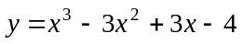 where the gradient is zero.

4 marks | Description
1 | 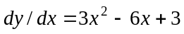 ✓
1 | if 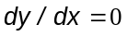then 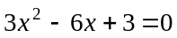  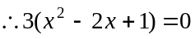  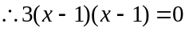✓
1 | so x = 1 ✓
1 | substituting gives y = -3, the gradient is 0 at (1, -3) ✓

Question 2
Determine the equation of the line tangential to the curve 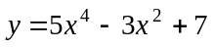 at the point where
x = 1.

4 marks | Description
1 | 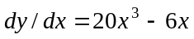 ✓
1, 1 | at x = 1, y = 9 ✓, 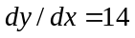 ✓
1 | using 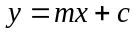, 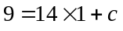, c = -5  the equation of the tangent 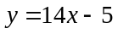 ✓
1 | or  using 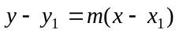, the equation of the tangent is:  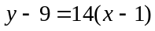  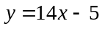✓

Question 3
Given 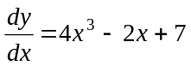 and y = 5 when x = -1, determine y as a function of x.

3 marks | Description
1 | 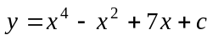 ✓
1 | substituting x = -1 and y = 5 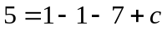 ∴ c = 12 ✓
1 | 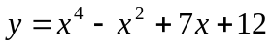 ✓

Question 4
(a) Describe in words how P varies with l.

2 marks | Description
1  1 | P is inversely proportional to l, ✓  As l increases, P decreases ✓ (or as l decreases, P increases).

(b) What would be a suitable domain for l? Justify your choice.

2 marks | Description
1  1 | l >0 ✓  as a pipe must have a length to exist ✓
or  1 | or  l >0 ✓
1 | as 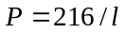 does not exist if l is zero and lengths would always be positive. ✓

(c) Graph the function P, using the axes below:
l
100
P
100

3 marks | Description
1  1  1 | Sketch in first quadrant ✓  Hyperbola close to symmetrical ✓  Asymptotic behaviour as the curve approaches horizontal and vertical axes ✓

(d) What is the pitch for a pipe with length 3 metres?

2 marks | Description
1  1 | P = 216/3 ✓  = 72 cycles per second ✓ (no units no mark)

(e) (i) Is P increasing or decreasing as l increases and l = 3?

1 mark | Description
1 | Decreasing ✓

(ii) What units would the rate of change of P be measured in for the 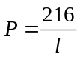 relationship?

1 mark | Description
1 | Cycles per second per metre ✓

Question 5
(a) What restrictions are there on S?

2 marks | Description
2 | 0 ≤ S ≤ 300 (no penalty for < instead of ≤)  ✓ ✓

(b) (i) What is his fitness index?

2 marks | Description
1 | 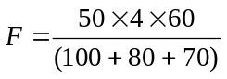 ✓
1 | = 48 ✓

(ii) What rating would he get?

1 mark | Description
1 | Poor ✓

(c) (i) Pulse rates (r) are between 50 and 140. Express this as a restriction on R.

1 mark | Description
1 | 150 < R < 420 ✓ (no penalty for ≤ instead of <)

(ii) Give an example of 3 measured pulse rates after 4 minutes of exercise that would result in a ‘Good’ rating and verify this by calculation

2 marks | Description
1 | 55,52,53 ✓ (or any other valid set)
1 | F=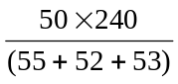=75 ✓

(d) Find the equation of the line between the categories ‘Excellent’ and ‘Good’.

3 marks | Description
1 | F = 80 ✓
1 | 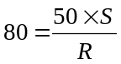✓
1 | S = 1.6R ✓

(e) Shade the region that represents an ‘Excellent’ rating, on the graph above.
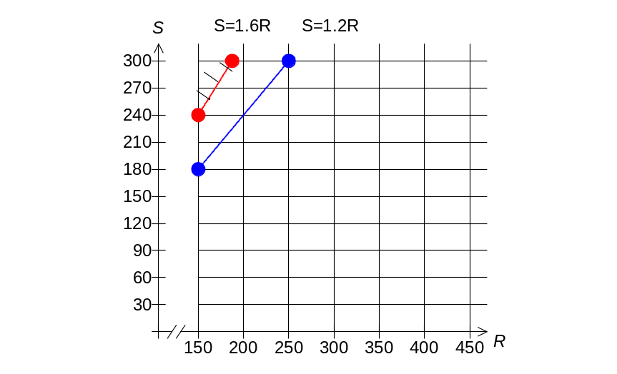

3 marks | Description
1 | Line S = 1.6R ✓
1 | Restricted range ✓ (S ≤ 300)
1 | Shading above ✓

(f) An extra rating of ‘Very Poor’ is introduced for a fitness index of below 50. Explain why
S = R is the line forming the boundary between ‘Poor’ and ‘Very Poor’ and add this line to the graph above.
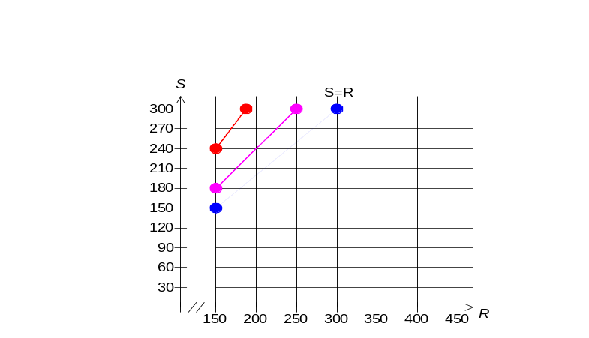

3 marks | Description
1 | F = 50  50 =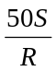✓
1 | 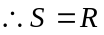  S = R line on graph (dotted or solid) ✓
1 | S ≤ 300 ✓ (correct range)

(g) Shade the region on the graph that represents a ‘Very Poor’ rating.

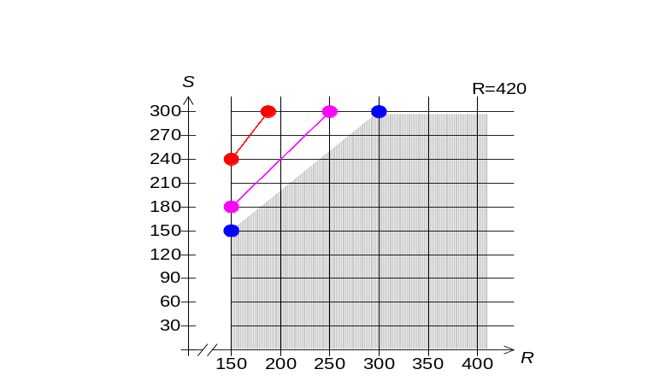

1 mark | Description
1 | Shade below and to the right of the line S = R, between 150 ≤ R ≤ 420,  for S ≤ 300 ✓ (line should be dotted, no penalty for solid)

RESOURCE-RICH EXAMINATION

Question 1
(a) Display this data in the table below, then complete the table.

 | In favour | Against | Undecided | Total
Male | 51 | 40 | 3 | 94
Female | 70 | 31 | 5 | 106
Total | 121 | 71 | 8 | 200

2 marks | Description
2 | All entries correct ✓✓  (- 1 for 1 or 2 errors, -2 for 3 or more errors)

(b) If an adult from the survey is chosen at random, find the probability that this adult is:

(i) a male in favour of the proposal.

1 mark | Description
1 | 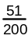✓

(ii) a male, given the adult is against the proposal.

2 marks | Description
2 | 40 ✓ 71 ✓

(c) If a male is chosen at random from the male group surveyed and a female is chosen at random from the female group surveyed, who is more likely to be in favour of the proposal? Justify your answer.

3 marks | Description
1 | P(favour I male)= 51/94 ✓ (≈ 0.543)
1 | P(favour I female)= 70/106 ✓ (≈ 0.660)
1 | 70/106 > 51/94  hence the female is more likely to be in favour ✓

Question 2
(a) Determine the length of QS.

3 marks | Description
1 | QS =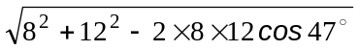 ✓ (states the rule with the correct values)
1 | ≈ 9m or 8.8m or 8.78 m ✓ (8.77817.. rounded )
1 | ✓ (rounding is correct and units stated throughout the question--in parts a and b and c)

(b) Given angle R is acute, determine the size of angle QRS.

2 marks | Description
1  1 | sin ∠QRS = 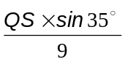✓ (states sine rule with the appropriate lengths/values)  ∠QRS ≈ 34.02° ✓ (34.01702…rounded)

(c) Determine the area of quadrilateral PQRS.

2 marks | Description
1 | Area PQRS=Area triangle PQS + area triangle QRS  = ½ x 8 x 12 sin47° + ½ x QS x 9 x sin ∠QSR ✓
1 | (states areas with appropriate lengths/angles/values)  ≈ 72 m ² ✓ (71.98726.. rounded)

Question 3
(a) Determine Kim’s bicycle riding speed in metres/second.

2 marks | Description
1  1 | Speed ≈ 1.25 km in 5 min ✓ (or use kilometres close to 1.25)  ≈ 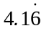 m/s ✓

(b) Determine the speed of the car in kilometres per hour.

2 marks | Description
1  1 | Speed ≈ (3 - 1.25)/2 km/min ✓  ≈ 52.5 km/h ✓

(c) If Kim had ridden her bicycle all the way to school at the same speed as in the first leg of the trip, would she have arrived at school earlier, later or at the same time? Justify your answer.

3 marks | Description
1  1  1 | extending the line for the bicycle ride ✓  shows she would have arrived at school after about 14 minutes, ✓  therefore she would have arrived earlier ✓
or  1 | or  The graph indicates the school was 3.5 km from where Kim started, so travelling at (1.25/5 km per minute) ✓
1 | she would have arrived after 14 minutes. ✓
1 | Therefore she would have arrived earlier. ✓
or
other method (reasoning ✓✓ and conclusion ✓)

Question 4
(a) Draw a project network which satisfies the above conditions:
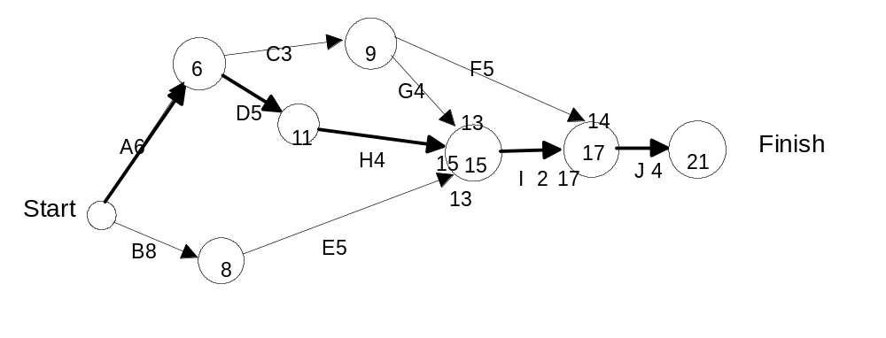

3 marks | Description
3 | Draws full diagram correctly with letters, numbers, start/finish ✓✓✓ (-1 for each error or omission)

(b) Determine the minimum time to complete the project and state the critical path, if all tasks are completed on time.

2 marks | Description
1  1 | 21 days ✓  critical path as A-D-H-I-J ✓

(c) If task C were to be delayed by 3 days, what effect, if any, would this have on the completion time?

1 mark | Description
1 | project would take 1 more day ✓ (or 22 days to complete)

(d) If task D were to be shortened by 3 days, what effect, if any, would this have on the completion time?

1 mark | Description
1 | project would take 2 days less to complete ✓ (or 19 days to complete)

Question 5
(a) How many students sat for the examination?

1 mark | Description
1 | 119 ✓

(b) Describe student performance in the examination.

6 marks | Description
2 | The average score was 67% (mean score)  The student ranked in the middle of the class (60th) obtained a score between 61-70 inclusive (comments on an average ✓ gives an appropriate figure✓)
2 | The spread of scores for the whole group of students was large (range about 89%) but most of the students scored above 50% and less than 91% resulting in a standard deviation of 18.6%  (comments on the spread of the scores ✓ gives the range and standard deviation ✓)
2 | The distribution of scores was skewed to the left (negatively skewed) because most students scored more than 50%, and a few students had very low scores (2 between 11–20 inclusive, 4 between 21–30 inclusive, 15 between 31–50 inclusive.)  (identifies direction of the skew ✓, explains the skew which could include mentioning the modal class 71–80 ✓)

Question 6
(a) (i) Use the more appropriate of the two lines of regression to estimate the mark on Test 2 for a student who scored 4 on Test 1.

1 mark | Description
1 | using line L2 and x = 4  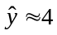 ✓

(ii) Justify why you used that particular line of regression and comment on the reliability of your prediction.

2 marks | Description
1 | Line L2 was used because it fits the central band of data better than line L1 and the prediction is within this band. ✓
1 | Reliability is reasonable, judging by the correlation coefficient r = 0.928 and because the prediction involves interpolation ✓

(b) (i) Use the more appropriate of the two lines of regression to estimate the mark on Test 2 for a student who scored 11 on Test 1.

1 mark | Description
1 | using line L1 and x = 11 , 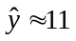 ✓

(ii) Explain why you used that particular line of regression and comment on the reliability of your prediction.

2 marks | Description
1  1 | Line L1 was used because it is closer to data values near the prediction than is line L2 ✓  The prediction is not reliable because it involves extrapolation ✓

Question 7
(a) Show that the height, in terms of the base, is given by the expression 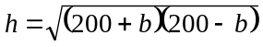

2 marks | Description
1 | 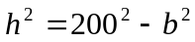 ✓
1 | 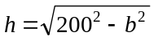  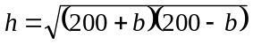✓

(b) Complete the following table (to two decimal places):

Base, b (m) | Height, h (m) | Area, A (m²)
90 | 178.61 | 8037.26
100 | 173.21 | 8660.25
110 | 167.03 | 9186.81

2 marks | Description
1 | Both values correct for when b = 100 ✓
1 | Both values correct for when b = 110 ✓ (no penalty for rounding final answers incorrectly, -1 if Area is incorrect because of carry through errors i.e. height to 2 decimal places was used)
(c) Determine the maximum area showing clearly the method used:

4 marks | Description
1 | Area = 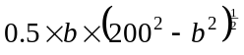 ✓
2 | 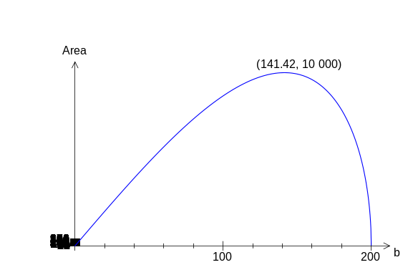  Graph ✓ maximum point labelled ✓
1 | Max area = 10 000 m² ✓
or  1 | or  Area = ✓
1 | Max area = 10 000m² ✓ read from the table of function values on a calculator, at
2 | b = 141.4 m ✓✓
or
by calculation (beyond the requirements of Units 3A/B)
base height area
130 9879
140 9998
141 9999.8
141.4 999.9995
141.42 10000

or by calculus (derivative is beyond Units 3A/B)

Question 8
(a) Complete the table below showing the starting population for each year from 1995 to 2007.

P_{t} | Year | Beginning population
P_{o} | 1995 | 400
P₁ | 1996 | 440
P₂ | 1997 | 484
P₃ | 1998 | 39
P₄ | 1999 | 89
P₅ | 2000 | 183
P₆ | 2001 | 290
P₇ | 2002 | 304
P₈ | 2003 | 298
P₉ | 2004 | 301
P₁₀ | 2005 | 299
P₁₁ | 2006 | 300
P₁₂ | 2007 | 300

4 marks | Description
2  2 | 440 ✓ 484 ✓  89, 183, 290 ….. ✓✓ (truncated answers—rounded answers also acceptable)

(b) (i) What type of function is P = k(a)^{t} ?

1 mark | Description
1 | Exponential ✓

(ii) Give the values of k and a.

2 marks | Description
1 | k = 400 ✓
1 | a =1.1 ✓

(c) (i) What population size will the European wasps level out at if the sterilisation program continues?

1 mark | Description
1 | 300 ✓

(ii) Explain mathematically why the population levels out.

3 marks | Description
2 | When 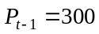  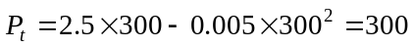✓✓
1 | and every following 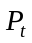 term will calculate to be 300. ✓

(e) Sketch the population graph.
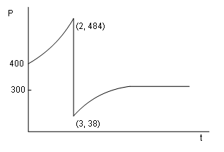

4 marks | Description
1 | y intercept 400 ✓
1 | First section an exponential curve ✓
1 | Highest point level with 484✓and lowest point level with 38 (or 38.72) and
1 | Levels off level with 300 ✓

Question 9
(a) Calculate the values in the cells denoted by A and B.

2 marks | Description
2 | A = 584 ✓ B = -38 ✓

(b) The equation of the trend line for the moving averages is y = 1.476t + 563.497 (with correlation r ≈ 0.944). Predict the sales (to the nearest 50 cents) for Monday of Week 5.

3 marks | Description
1 | t = 21  From the trend line = 594.493 ✓
1 | Seasonal component for Mondays = (70+68+72)/3 = 70 ✓
1 | Predicted sales with seasonal adjustment  = $594.493+ $70  = $664.50 to the nearest 50c ✓

(c) Comment on the reliability of your prediction in (b), using mathematical reasoning.

2 marks | Description
1,1 | - the high correlation coefficient and  - the fact that the prediction is close to provided data indicate the prediction should be reliable.  However, the requirement for extrapolation brings reliability into doubt. ✓✓ (Two valid observations)

(d) Comment on the reliability of your prediction in (b), in terms of the context.

1 mark | Description
1 | The sales in a school canteen do not always follow a pattern because of special events such as sports carnivals, and sales could be zero on Monday because of a long weekend. Thus, the prediction might not be reliable because the school calendar has not been taken into account. ✓ (One plausible observation and a conclusion about reliability)

Question 10
(a) What proportion of students scored less than 100 marks?

2 marks | Description
2 | X : mark scored , X~N(124, 30²)  P(X<100) ≈ 0.21186 ✓✓ (1 for probability notation, 1 for correct decimal)

(b) The top 2% of students were awarded a certificate of distinction. What minimum mark was needed for a certificate of distinction?

2 marks | Description
1,1 | Let x be the minimum mark for a distinction  P(X> x)=0.02  x ≈ 185.6 ✓✓ (Answer only sufficient, 1 mark if correct setup and wrong answer)

(c) The middle 40% of students received a grade of C. What were the minimum and maximum marks in order for a student to be awarded a C?

3 marks | Description
1 | Let maximum mark be k and minimum mark be c  P(X < k) = 0.7, k ≈ 139.7 ✓
1 | P(X < c) = 0.3, c ≈ 108.3 ✓
1 | If whole marks only then maximum mark is 139 (or 140) and minimum mark is 108 (or 109) ✓
 | Or if half marks allowed, maximum mark is 139.5 (or 140) and minimum mark is 108.5 (or 108)

